Research Supervisors
AY 2021-22
S.No | Name of the Research supervisor | Department | Area of Specialization | Name of the  Scholar | Weblink for  Allotment Order
1 | Dr. Rayudu V V Krishna | ECE | Image Processing | Padala Ramesh Kumar | View Document
 |  |  |  | Mr.P Srinivas | View Document
2 | Dr. V Vijayasri Bolisetty | ECE | Wireless Communication | Mr.R.Lal Raja Lokesh Babu | View Document
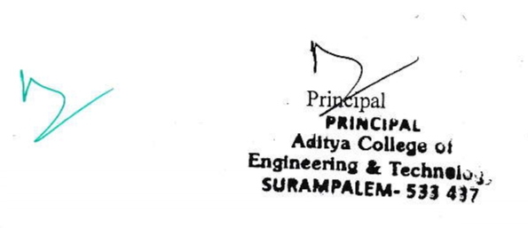
Web Link:
http://www.acet.ac.in/?p=Research_Supervisors

